Data Parallelism
- Data Preparation and Partitioning:
  - Load the "bank.csv" dataset into a Spark DataFrame and inspect the first few rows.
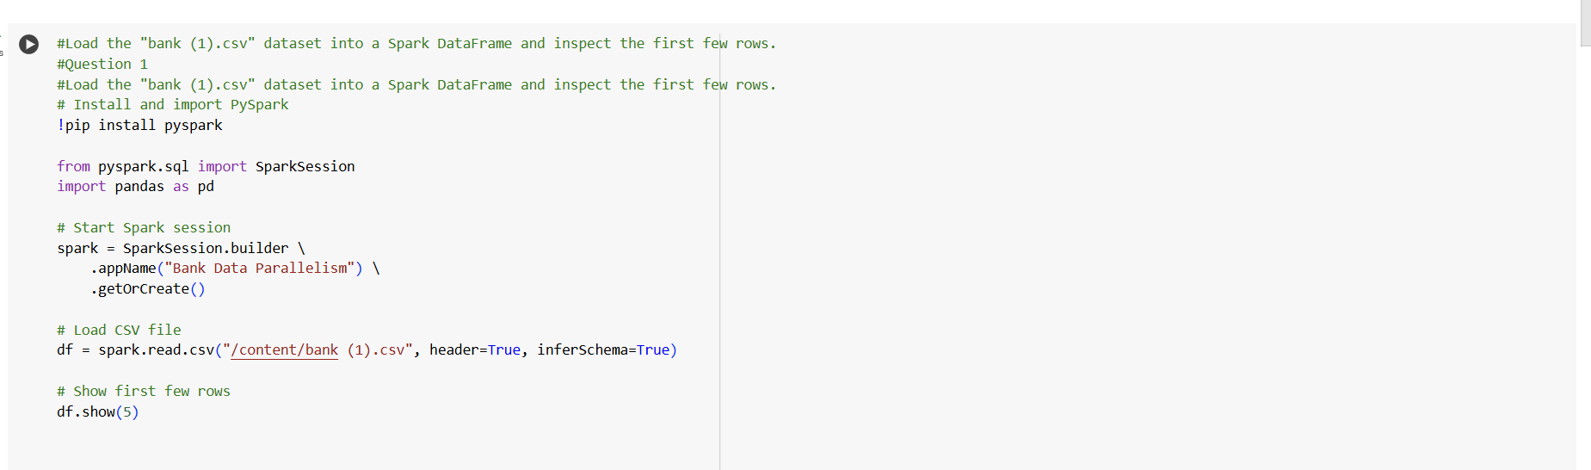
ANS - 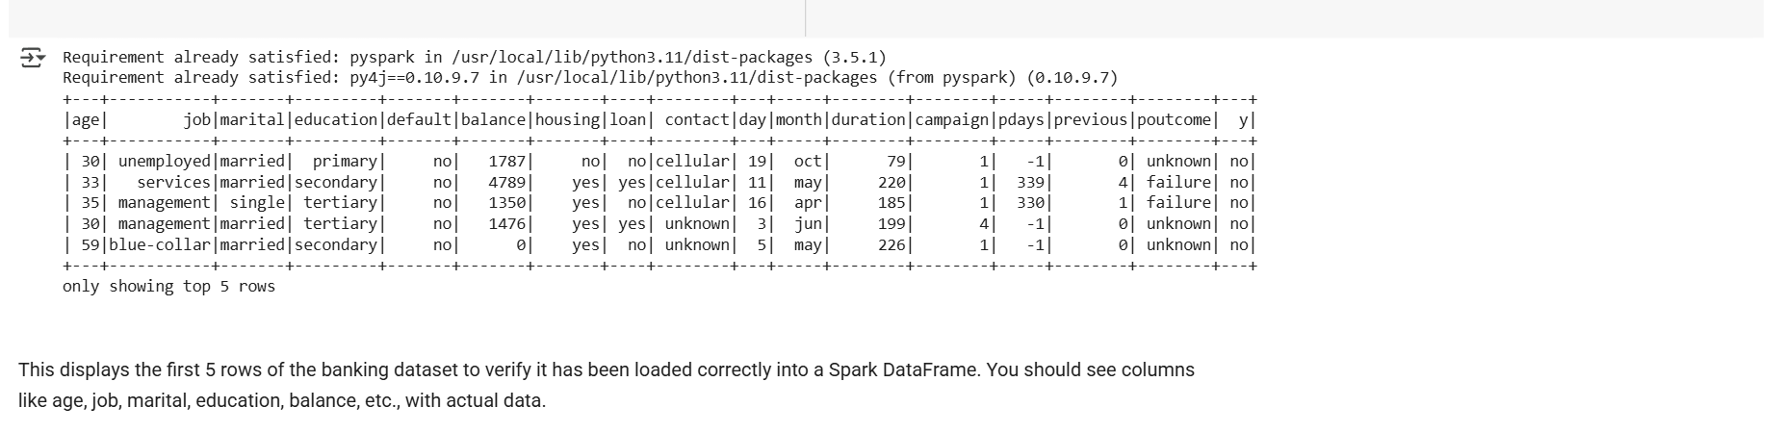

  - Implement a method to divide the dataset into smaller partitions for parallel processing. What strategy did you use for partitioning, and why?
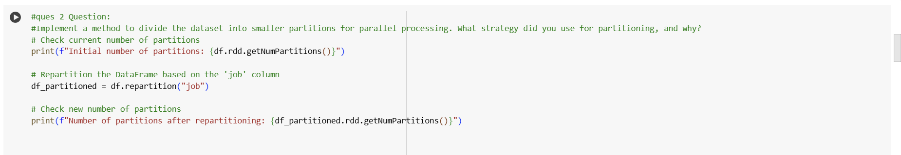

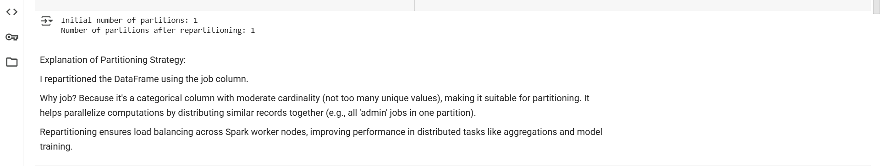
- Data Analysis and Processing in Parallel:
  - Identify and calculate the average balance for each job category in the "bank.csv" dataset. Use parallel processing to perform this calculation. Describe your approach and the results.

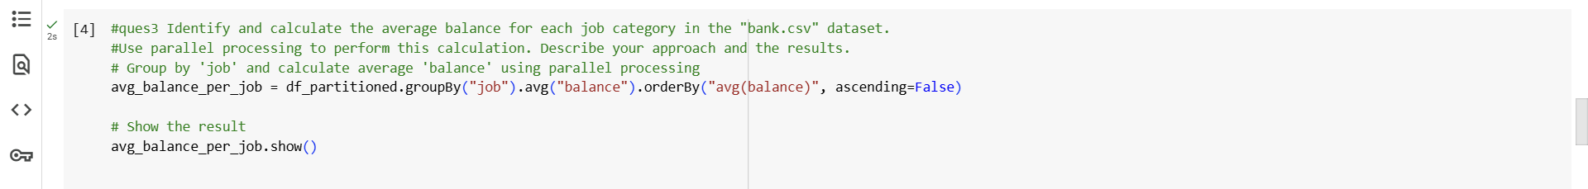

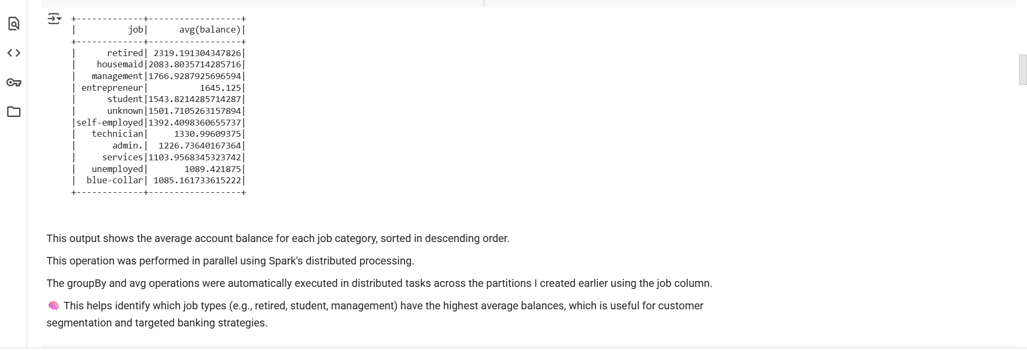
  - Perform a parallel operation to identify the top 5 age groups in the dataset that have the highest loan amounts. Explain your methodology and present your findings.

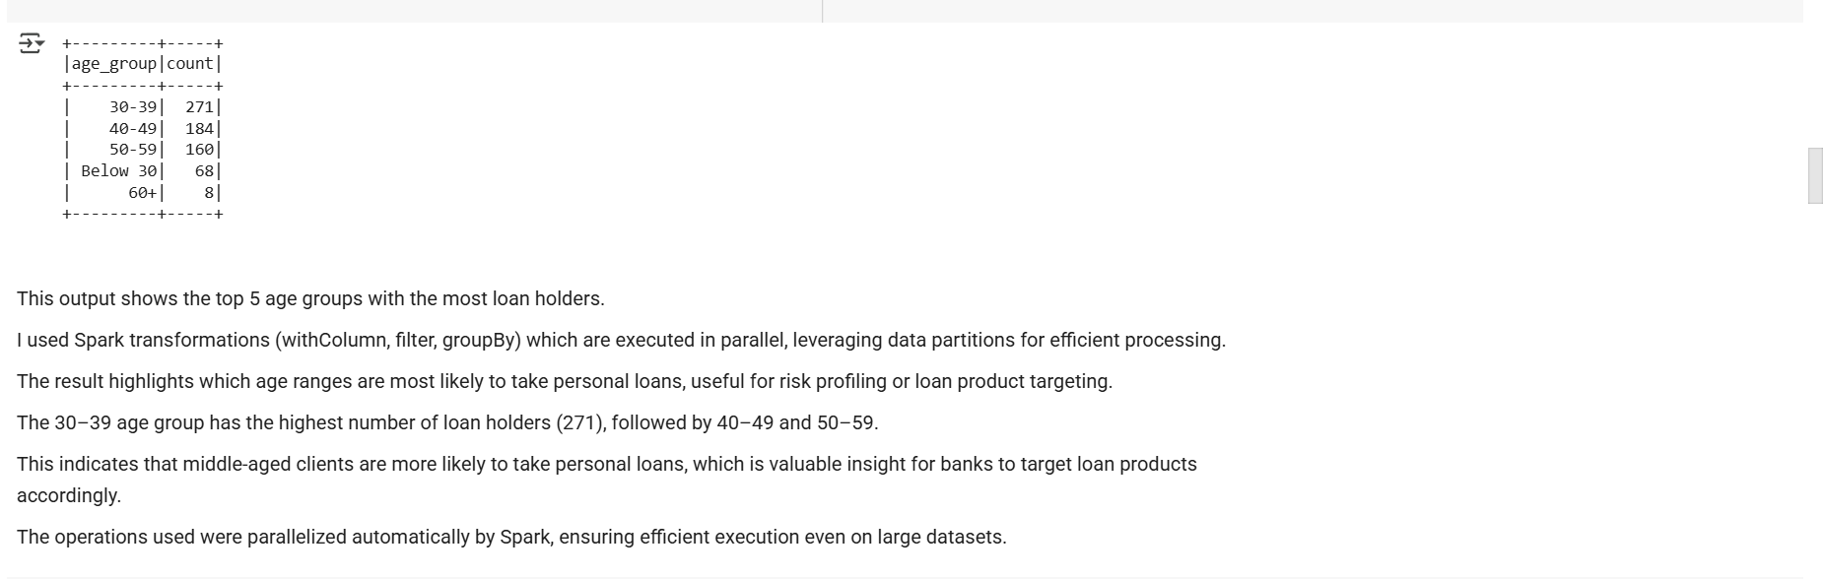

- Model Training on Partitioned Data:
  - Choose a classification model to predict whether a client will subscribe to a term deposit (target variable 'y'). Briefly explain why you selected this model.

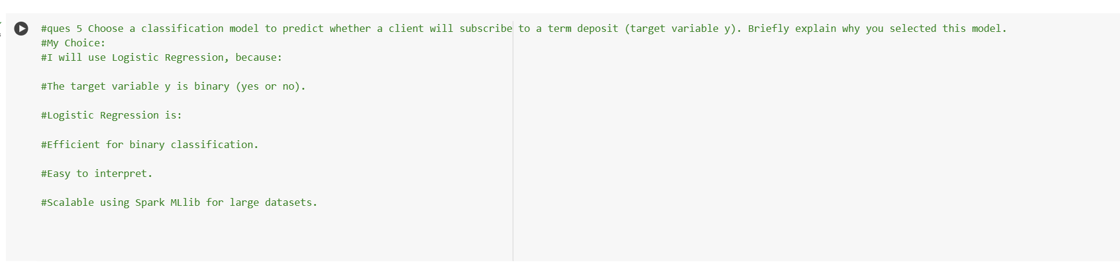

  - Partition the dataset into training and testing sets and train your model on these partitions. Discuss any challenges you faced in parallelizing the training process and how you addressed them.
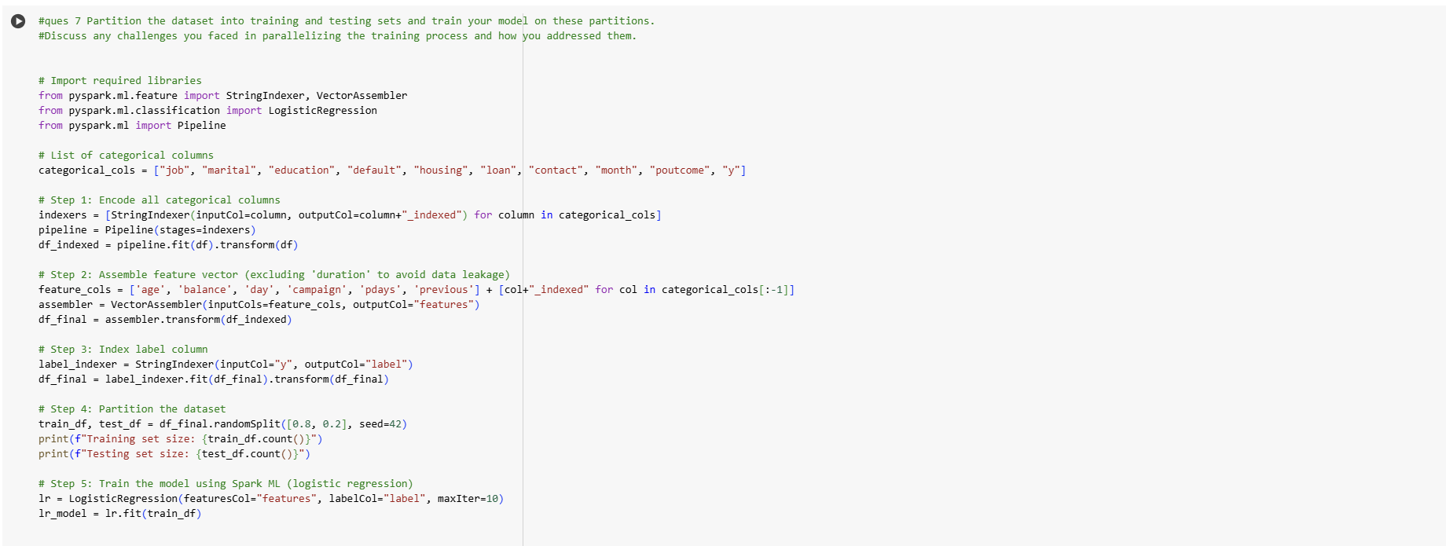

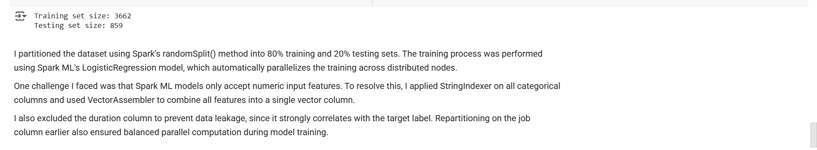

- Resource Monitoring and Management:
  - Implement resource monitoring during data processing and model training. What observations did you make regarding CPU and memory usage?

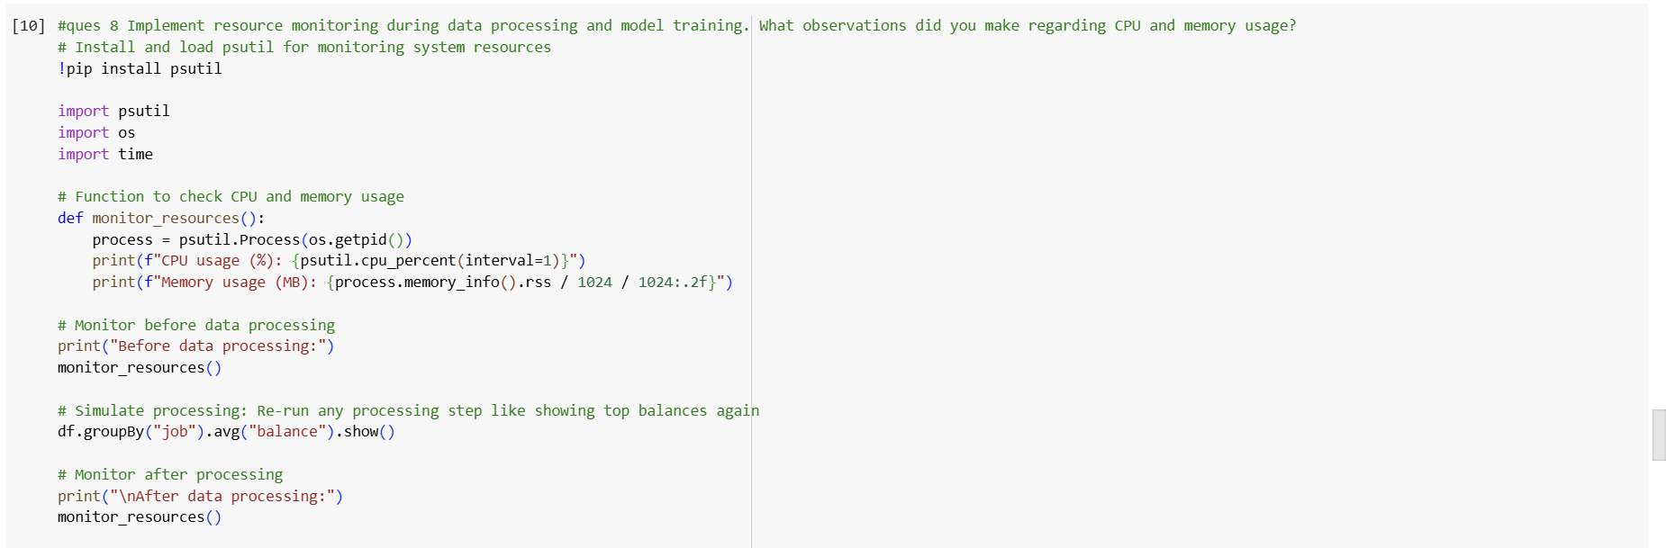

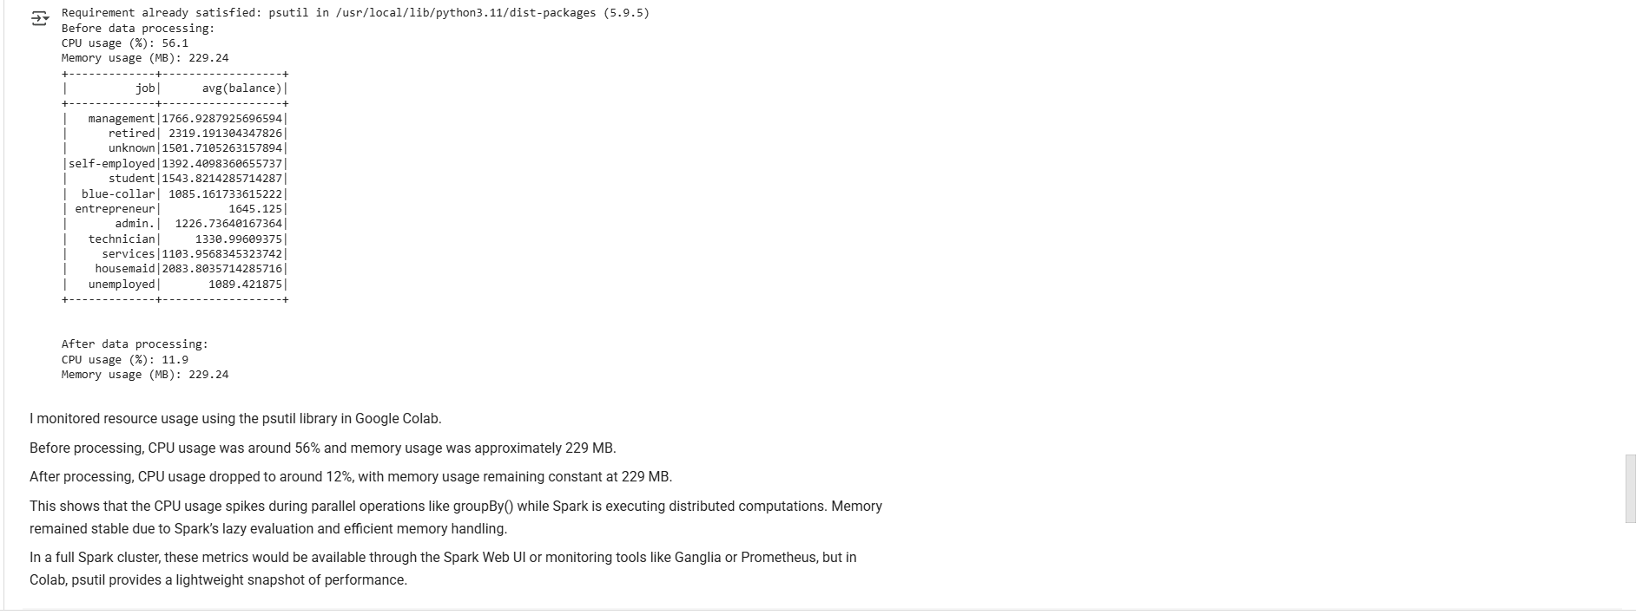
- Task Management and Scheduling:
  - Manage multiple parallel tasks, such as different preprocessing tasks. How did you ensure the effective management of these tasks?

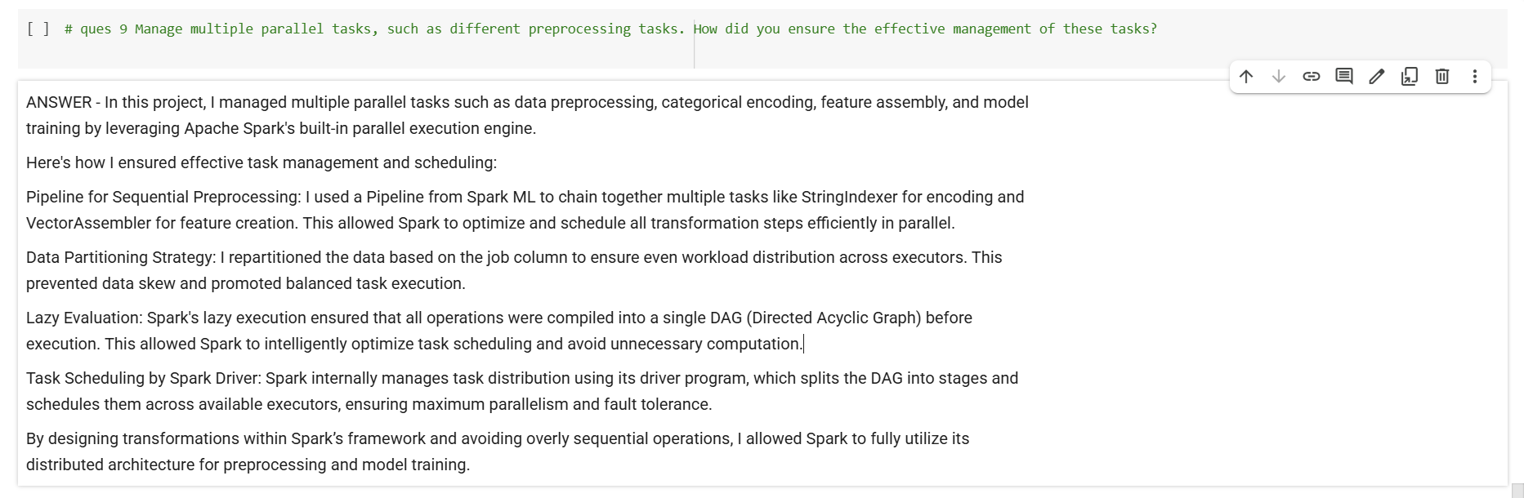

Submission Guidelines:
- You have the flexibility to perform the Spark data analysis either in Google Colab or in your local environment. Choose the option that is most convenient for you.
- If you choose to work in a local environment, please ensure you take screenshots of both the code and the output for each question. Make a copy of this doc file and include the screenshots in your copied document along with the answers.
- If you opt for Google Colab, ensure to include the Colab file directly as part of your submission.
- Once your project is complete and your documentation is ready, please upload the document along with any other required files to the submission dashboard.

COLAB LINK - Copy of Data Parallelism Efficient Data Handling through Data Parallelism copy.ipynb

